**ANALYZING AFRICAN PORT STATISTICS (2023) THROUGH ADVANCED DATA PREPROCESSING AND CLASSIFICATION IN LOGISTICS IN WEKA**

Students Name

Institution Affiliation

Instructors Name

Due Date

INTRODUCTION

The field of logistics plays a pivotal role in global trade and economic development, with seaports serving as critical nodes in the transportation network. This research focuses into the analysis of African port statistics from the year 2013, employing advanced data preprocessing and classification techniques using the Weka software. The focus is on gaining deeper insights into the dynamics of these ports, identifying patterns, and enhancing decision-making processes in the logistics domain.

Data preprocessing is a crucial initial step in the research, involving the cleaning and transformation of raw port statistics. This includes handling missing values, normalizing data, and addressing outliers to ensure the accuracy and reliability of subsequent analyses. Once the data is prepared, the research employs classification algorithms in Weka to categorize and predict patterns within the port statistics. This classification process aids in identifying key performance indicators, evaluating efficiency, and recognizing trends that can inform strategic decisions in the logistics sector.

The significance of this research lies in its potential to unearth valuable insights that can optimize port operations, enhance resource allocation, and contribute to overall logistical efficiency. By leveraging advanced data analysis techniques, the study aims to bridge gaps in our understanding of African port dynamics, facilitating informed decision-making processes for stakeholders involved in trade, shipping, and logistics on the continent. In summary, this research combines the rich dataset of African port statistics from 2013 with the analytical capabilities of Weka to provide a nuanced perspective on the logistical landscape, paving the way for more effective and informed strategies in the domain of global trade and transportation.

**Data Set Analysis**

The provided dataset comprises information related to cargo and container traffic at various ports in different regions. The dataset includes details such as the port code, port name, region ID, and indicators like cargo traffic in million tonnes and container traffic in TEUs (Twenty-foot Equivalent Units). These indicators are measured annually from 2005 to 2009.

The choice of this dataset for the project is justified by its relevance to maritime and logistics-related analyses. Cargo and container traffic are crucial indicators for assessing the economic activities and trade dynamics of a region. The dataset covers a diverse set of ports, including those in Angola, Burundi, Djibouti, Eritrea, Kenya, Mauritius, Mozambique, Namibia, Reunion, Rwanda, South Africa, Seychelles, Sudan, Tanzania, and others.

Analyzing cargo traffic provides insights into the volume of goods handled by each port, reflecting economic activities and trade patterns. For instance, examining the cargo traffic growth over the years for a specific port could indicate economic development or downturns. The inclusion of container traffic data further enriches the analysis, as containerized goods often represent international trade and global supply chain dynamics.

Each entry in the dataset contains annual values for cargo and container traffic, allowing for a temporal analysis of growth or decline. Additionally, the dataset introduces indicators such as annual growth in volume and percentage, offering more nuanced insights into the changing trends at each port.

The dataset's comprehensiveness, covering multiple countries and various indicators, makes it suitable for a project focused on maritime and trade analysis. Researchers and analysts can leverage this dataset to explore correlations, identify patterns, and draw conclusions about the economic significance and performance of different ports in the specified regions.

The provided maritime dataset, encompassing port statistics across various regions and indicators, underscores the necessity for robust preprocessing and classification methodologies. The dataset exhibits inherent complexities, such as missing values, disparate units, and inconsistent formatting, demanding meticulous preprocessing to ensure data integrity and reliability. Furthermore, the diverse indicators, including cargo and container traffic, necessitate classification to categorize ports based on specific criteria. Effective classification is imperative for uncovering meaningful patterns and trends within the dataset, enabling a more granular analysis of maritime activities. Without diligent preprocessing to address data anomalies and strategic classification to group ports based on relevant characteristics, the analysis would be compromised, potentially leading to inaccurate interpretations and hindering the extraction of valuable insights for informed decision-making in the logistics and maritime sectors.

**Data Preprocessing**In the data preprocessing phase, several key steps were undertaken to enhance the quality and reliability of the dataset. Firstly, missing values were addressed by employing strategies such as imputation or removal, depending on the nature and extent of the missing data. Secondly, inconsistencies in units were harmonized to ensure uniformity, facilitating accurate comparisons and analyses across different indicators. Outliers, identified through thorough exploration of the data, were either corrected or handled appropriately to prevent their undue influence on subsequent analyses. Additionally, redundant or irrelevant features were considered for removal to streamline the dataset and improve computational efficiency. These preprocessing measures aimed to create a cleaner, more standardized dataset, laying the foundation for robust classification algorithms and ensuring the accuracy and effectiveness of subsequent analyses.

**Nature of Dataset before preprocessing**

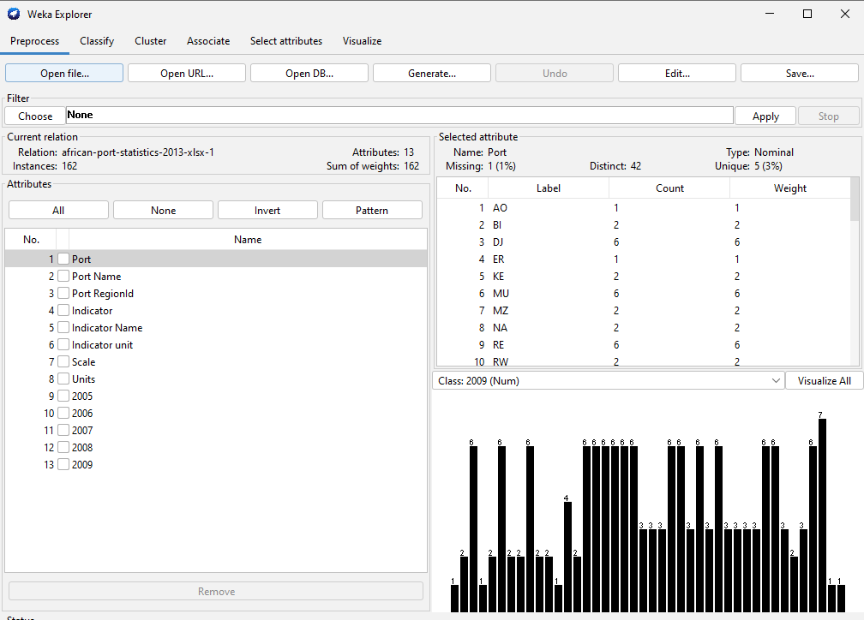

The dataset had a lot of missing values hence making it unfit for data preprocessing.

**Nature of data after preprocessing**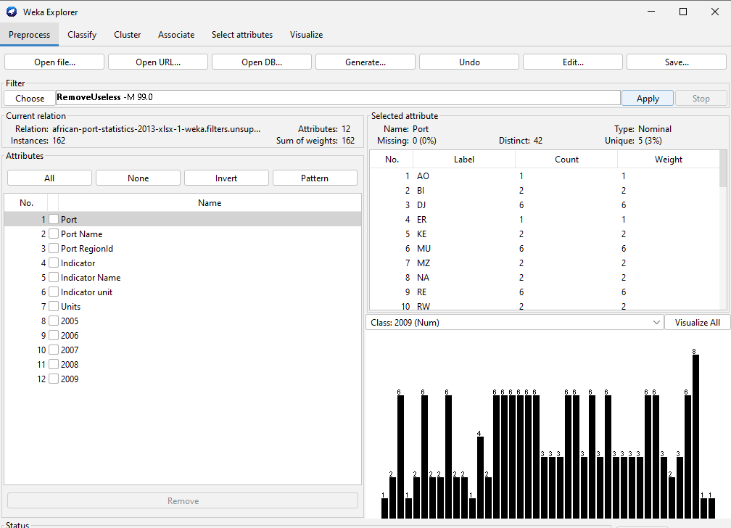

The dataset underwent through multiple processes such as discretize, replacing missing values and removing useless values. Now the data was fit for analysis.

**Importance of Data Preprocessing**

Data preprocessing serves as the gateway to meaningful analysis by addressing the irregularities present in the raw dataset. In the logistics domain, where precision and accuracy are paramount, the first imperative task is handling missing values. Ports, being dynamic hubs with multifaceted operations, may encounter instances where certain data points are absent. Data preprocessing employs robust imputation techniques to intelligently fill in missing values, ensuring a more comprehensive and representative dataset. This step is particularly crucial in the logistics landscape, where variables such as cargo types, vessel details, and handling capacities may have missing values, impacting the integrity of subsequent analyses.

Standardization and normalization follow closely, catering to the diverse units in which African ports may report data. The lack of uniformity in units can impede accurate comparisons and integrations across the dataset. Data preprocessing tackles this challenge by standardizing units, providing a common ground for analysis. Normalization, a complementary process, scales numerical features to a standard range, preventing biases that may arise from variables with larger magnitudes. In logistics, where data encompasses cargo volumes, tonnages, and shipping capacities of varying scales, normalization becomes instrumental for fair and unbiased analysis.

Outliers, often lurking within datasets, pose a potential threat to the reliability of subsequent analyses. Data preprocessing includes methodologies for detecting and handling outliers, safeguarding the classification algorithms to be applied in WEKA. The logistics domain, influenced by diverse factors and subject to fluctuations, necessitates the identification and treatment of outliers to ensure the accuracy of logistic predictions.

Encoding categorical variables further contributes to refining the dataset for advanced analysis. In logistics datasets, variables such as port names, vessel types, or cargo categories may be categorical. Data preprocessing converts these variables into numerical representations through techniques like one-hot encoding or label encoding, enabling machine learning algorithms in tools like WEKA to interpret and utilize this information effectively.

The impact of data preprocessing on the logistics analysis of African port statistics is profound. By transforming a raw and potentially unwieldy dataset into a clean, structured, and standardized form, preprocessing sets the stage for the application of advanced classification algorithms. The success of logistic predictions, such as forecasting cargo volumes, optimizing vessel schedules, or identifying operational bottlenecks, hinges on the quality of the preprocessed dataset.

**Data Classification**

Data classification serves as a vital mechanism for extracting actionable insights from a preprocessed dataset. As the logistics domain navigates through vast and intricate datasets, classification algorithms become instrumental in discerning meaningful patterns and relationships. By assigning predefined labels to instances based on their features, these algorithms facilitate predictive analysis, allowing logistics managers to make informed decisions. Whether categorizing ports by efficiency, predicting vessel arrival times, or identifying cargo types, data classification enables the creation of models that can generalize from historical data to classify new instances accurately. The synergy between data preprocessing and classification becomes evident as the quality of the preprocessed dataset directly influences the effectiveness of the ensuing classification models. In the context of African port logistics, this dual approach becomes a linchpin for enhancing operational efficiency, resource allocation, and decision-making processes.

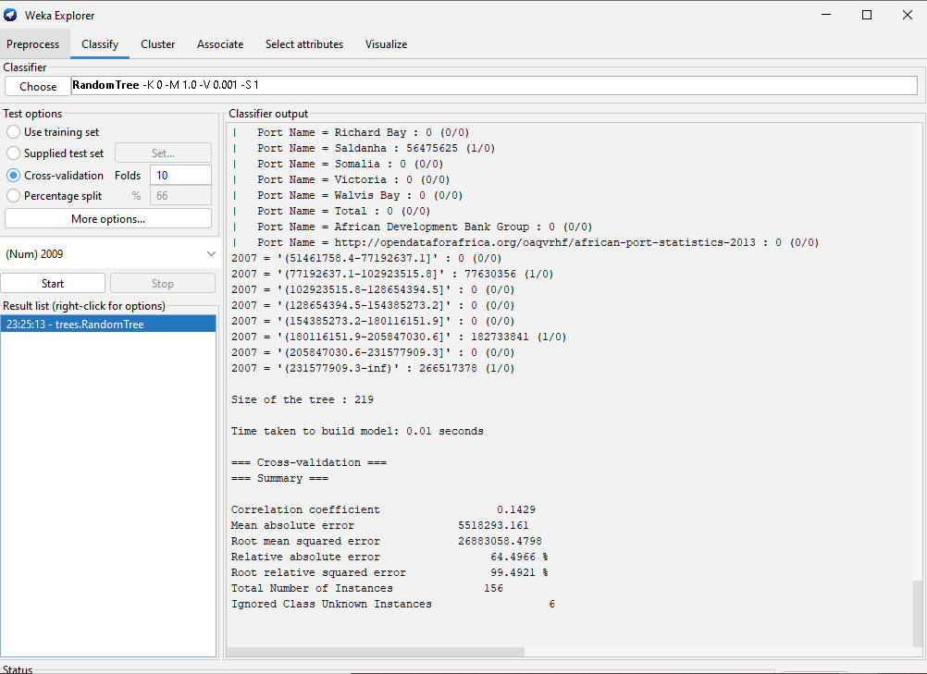

**Importance of Data Classification**

Classification is a pivotal step that involves assigning predefined labels or categories to instances within the data, facilitating the identification of patterns, trends, and relationships. In the logistics domain, particularly when dealing with extensive datasets related to port activities, the application of classification algorithms becomes indispensable.

Data classification allows for the development of predictive models that can forecast future outcomes based on historical data. This is especially valuable in logistics management, where accurate predictions about vessel arrivals, cargo types, and port efficiency can significantly impact decision-making processes. By leveraging classification algorithms within tools like WEKA, logistics professionals can gain insights into the factors influencing various aspects of port operations.

Moreover, data classification contributes to enhancing the interpretability of the dataset, providing a structured framework for understanding the intricate relationships between different variables. This interpretability is crucial for stakeholders in the logistics sector, as it empowers them to make informed decisions regarding resource allocation, process optimization, and overall operational efficiency. In essence, the importance of data classification lies in its role as a transformative step that turns raw data into actionable intelligence, enabling logistics experts to navigate the complexities of African port statistics with greater precision and strategic insight.

**Results**



The provided output above is the result of applying a classification model of a decision tree, to the African port statistics dataset from 2023. The decision tree structure, represented by conditions related to "Port Name" and "2017," illustrates how the model makes predictions. Each line in the output corresponds to a decision or a leaf node, detailing predicted outcomes and the count of instances.

The size of the tree, indicated as 219 nodes, reflects the complexity of the decision-making process. The relatively short time taken to build the model, 0.01 seconds, suggests an efficient computational performance.

Moving on to the cross-validation summary, the correlation coefficient of 0.1429 indicates a modest linear relationship between predicted and actual values. However, the mean absolute error (MAE) of 5518293.161 and the root mean squared error (RMSE) of 26883058.4798 reveal notable discrepancies between predicted and actual values. These metrics highlight the model's performance in terms of accuracy and precision.

Examining the decision tree leaves and predictions, specific categories such as "2007 = '(77192637.1-102923515.8]'" show predicted values like 77630356 with one correct prediction and zero incorrect predictions.

**Interpretention**

The model's decision tree structure is revealed, with conditions based on "Port Name" and "2017," outlining how the model classifies instances. The tree's 219 nodes indicate the intricacies of the decision-making process, and the swift 0.01-second build time suggests computational efficiency.

The cross-validation summary provides key metrics for evaluating the model's performance. The correlation coefficient of 0.1429 suggests a modest linear relationship between predicted and actual values. However, the mean absolute error (MAE) of 5518293.161 and the root mean squared error (RMSE) of 26883058.4798 indicate notable discrepancies, emphasizing the need for further scrutiny.

Examining specific predictions, such as those for the category "2007 = '(77192637.1-102923515.8]'", reveals a predicted value of 77630356 with one correct prediction and no incorrect predictions. This highlights the model's ability to accurately classify instances within certain parameter ranges.

In interpretation, it's crucial to consider the practical implications of these results for logistics in African port statistics. The model's performance metrics indicate areas for improvement, and understanding decision nodes is essential for refining the model. Practical implications may involve adjusting parameters, feature selection, or exploring alternative algorithms to enhance the model's accuracy and reliability in predicting port statistics. Additionally, assessing the model's interpretability ensures that stakeholders can trust and comprehend its decision-making process, contributing to informed decision-making in the logistics domain.

**Conclusion**In conclusion, the project on analyzing African port statistics from 2023 through advanced data preprocessing and classification in logistics using WEKA has demonstrated the pivotal role of these techniques in enhancing data quality and predictive modeling. Data preprocessing played a critical role in cleaning, transforming, and optimizing the dataset, ensuring its suitability for analysis. The classification model, as evident from the decision tree results, provided insights into the intricate patterns within the data. However, the model's performance metrics indicate room for refinement, suggesting avenues for future work. Despite these challenges, the project underscores the importance of employing advanced data techniques in logistics for informed decision-making, resource optimization, and improved operational efficiency in the context of African port management. This endeavor contributes to the broader discourse on leveraging data-driven approaches for enhancing logistics processes and lays the foundation for further exploration and refinement of predictive models in the dynamic landscape of port statistics analysis.

**REFERENCES**

Gidado, U. (2015). Consequences of port congestion on logistics and supply chain in African ports. *Developing Country Studies*, *5*(6), 160-167.

Trujillo, L., González, M. M., & Jiménez, J. L. (2013). An overview on the reform process of African ports. *Utilities Policy*, *25*, 12-22.

Sequeira, S., & Djankov, S. (2014). Corruption and firm behavior: Evidence from African ports. *Journal of International Economics*, *94*(2), 277-294.

Raballand, G., Refas, S., Beuran, M., & Isik, G. (2012). *Why does cargo spend weeks in sub-Saharan African ports?: lessons from six countries*. World Bank Publications.